cnc_pdf_searchword

声明
/* line edit (search string) */
[DllImport("FWLIB32.dll", EntryPoint="cnc_pdf_searchword")]
public static extern short cnc_pdf_searchword( ushort FlibHndl, [In,MarshalAs(UnmanagedType.AsAny)] Object a , uint b , uint c , uint d , uint e , [In,MarshalAs(UnmanagedType.AsAny)] Object f );

描述
搜索程序字符。
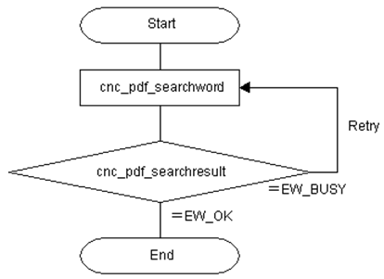

参数
（1）FlibHndl 库句柄；[ in ]
（2）prog_name 程序号 [ in ]
（3）line_no 行号 [ in ]
（4）type 类型 [ in ]
0 : Character search (Search the one address character.)
1 : Word search (Search the string by word basis.)
2 : Last line search (Search the bottom of line)
（5） direct [ in ]
0 : Search towards the top of the program.
1 : Search towards the bottom of the program.
（6）repeat [ in ]
（7） prog_data [ in ]

函数返回值
函数运行正常返回EW_OK。
Return code | Meaning/Error handling
EW_BUSY  (-1) | Busy  CNC is searching the program text right now.
EW_DATA  (5) | Data error  In order to get more information for this err_no return value, execute cnc_getdtailerr function. The following detail status will be set onto the member, err_no of ODBERR structure.
  1 | : | The program name(prog_name) error
  3 | : | The search type(search_type) error
  4 | : | The search direction(search_direct) error
  5 | : | The repeat count(repeat) error
  6 | : | The size of string error
  7 | : | The content of the string error
EW_NOOPT  (6) | No option  The extended driver/library function is necessary.
EW_PROT  (7) | Write protection in CNC side  CNC parameter is a state of write-protection(O8000-/O9000- protection, encoding).
EW_MODE  (12) | CNC mode error
EW_REJECT  (13) | CNC execution denied  - CNC is in the emergency stop.

代码
class Program
{
static void Main(string[] args)
{
ushort Flibhndl = 0;

short ret; // 返回值

// 获取库句柄 ( Ethernet )
ret = Focas1.cnc_allclibhndl3("192.168.0.224", 8193, 10, out Flibhndl);
if (ret != Focas1.EW_OK)
{
Console.WriteLine("发生异常，请检查！");
return;
}

#region cnc_pdf_searchword & cnc_pdf_searchresult

short serach_no=0;

string prog_name = "//CNC_MEM/USER/PATH1/O0888";
uint line_no=0;
uint type = 0;
uint direct = 0;
uint repeat = 100;
string prog_data = "M06";
do
{
ret = Focas1.cnc_pdf_searchword(Flibhndl, prog_name, line_no, type, direct, repeat, prog_data);
ret = Focas1.cnc_pdf_searchresult(Flibhndl, out serach_no);
}
while (serach_no == -1);

#endregion
}
}

